This manual is intended only as a guide for
Aspire’s X-Infinity Computer Enclosure. For more
comprehensive instructions, please refer to
the user’s manual which comes with your
components and drives.

Basics
1. Take the case out of the box.

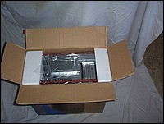
2. Remove the Styrofoam.

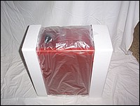
3. Remove the plastic bag.

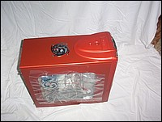
4. Remove protective film from side panel and front bezel.

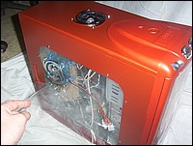
5. Remove the thumb screws from the side panel. Keep these screws separate from the other screws.

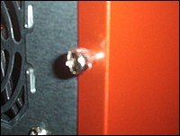

6.. Slide side panel back and off of the case
7. Inside the case you should see the power supply, some wiring (LED’s
etc.), an installed I/O panel, a power cord and a box containing
more hardware (screws, brass standoff, etc.).

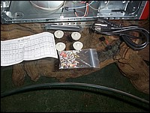

Motherboard Installation
This manual is not designed to cover CPU or RAM or expansion card installation.
Please consult your motherboard manual for specific mounting
instructions and trouble-shooting.

1. Lay the case down so that the open side is up. You should be able to
see the drive cage and power supply.
2. Locate the motherboard standoffs in the bag of screws provided and install them in the appropriate locations for your motherboard. There Are two types of standoffs provided.

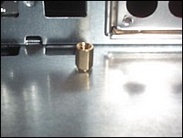. 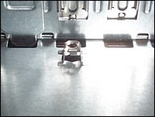
3. Make sure you have the appropriate I/O panel for your motherboard. If
the panel provided is not suitable for your motherboard you should
contact your motherboard manufacturer to get the right I/O panel.

4. Line up motherboard with standoff holes, and determine which ones
line up and remember where they are. (Note: Not all motherboards will
match with all of the provided screw holes, and this is not necessary
for proper functionality. In other words, there will likely be extra holes.)

5. Place your motherboard on the brass standoffs.

6. Screw in your motherboard to the standoffs with the provided metallic
Phillips head screws.

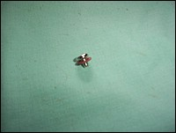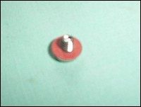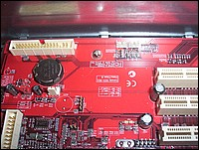

Power Connections
ATX power supplies have a single 20-pin (single large) power connector
to the motherboard. This is set up as a double row of 10 pins.
1. Connect the 20-pin ATX power connector to your motherboard.

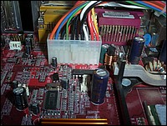

LED’s and Front Panel Leads
1. Reset (labeled RESET SW) connects to your motherboard at the RST
connector. The label should be facing the front of the case, and for
all of the following connectors as well.

2. Power LED (labeled POWER LED) connector is located behind the
Reset connector.

3. Power Switch (labeled POWER SW) connects to the PWR connector
on the motherboard.

4. Speaker (labeled SPEAKER) connector is behind the PWR connector.

5. Hard Drive LED (labeled HDD.LED) connects to the IDE connector.

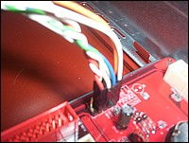

Temperature Sensor
The front panel has an LED temperature readout, the temperature sensor can be placed anywhere inside the case to monitor temperatures, for monitoring CPU temperatures place the sensor next to the CPU.

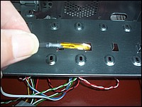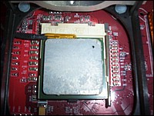

Front/Top USB ports
Consult motherboard manual for location of USB headers

1. Connect front/top USB cable to USB header on motherboard.

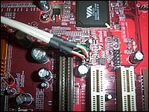

Front/Top Audio
The X-infinity comes with front audio plugs for headphones and a microphone.

1.Run audio/mic cables through notched PCI cover at the rear of the case.

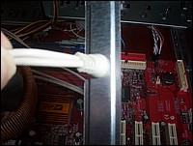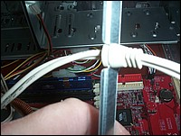
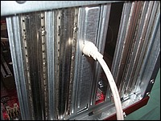

3.5” Device Installation
1. The floppy drive bays are located above the temperature monitor and below the CD ROM bays

2. Slide floppy drive into the 3.5” bay from outside the case and secure with screws provided

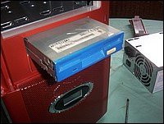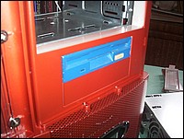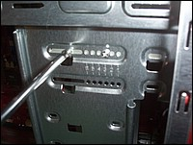

3. Install your other 3.5” devices to the drive cage accordingly.

4. Connect a 4-pin white connector from the power supply to the male
4-pin connector on each of the devices.

5.25” Device Installation
1. Looking from inside the case you will see metal plates covering the 5.25” bay slots, these will need to be removed in order to install your devices. Carefully remove the plastic bay covers to reveal the metal plates.

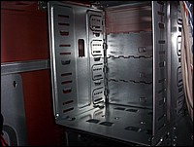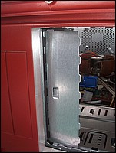
2. Use your hands to twist the metal plate back and forth until it breaks off.

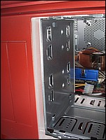

3. Fasten your 5.25” device into the drive bay with screws provided.

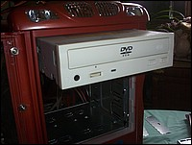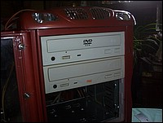

4. Repeat the same procedure for other devices.

5. Connect a 4-pin large white connector from the power supply to the
male 4-pin connector on each of the devices.

Hard Drive Installation
Hard drives are installed in much the same way as a CDROM or floppy drive, the only difference being they are installed from inside the case rather then the outside.

1. Slide hard drive into hard drive cage

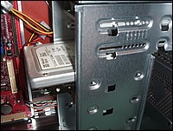

2, Secure with screws provided

IDE Cable Connection
This is for IDE devices only.
1. After you have connected the devices to the power supply, you need to
connect the IDE cables between the devices and the motherboard.

2. For hard drives and CD ROMs use the 40-pin IDE ribbon cables. For
floppy drives use the 34-pin IDE ribbon cables. These should come
with your devices and have a red stripe on side. When you connect a
ribbon cable to a device make sure that the red stripe is toward the
power connector.

3. The side that attaches to your devices should be the side that has 2
connectors. This will enable you to connect another device if
you wish.

4. Connect the far end of the cable to your motherboard on the IDE port,
either IDE 1 or IDE 2. (IDE 1 is generally for your hard drives, and IDE 2 is for your CDROM drives)

Fan Installation
The X-Infinity case has space for two 80mm optional fans that can be installed in the lower front of the case, and 1 80-120mm fan in the rear (the side panel and top fan are pre installed)

Front Fans
1. Two 80mm fans can be installed in the lower portion of the case near the drive cages

2. Remove the front bezel

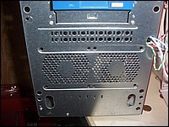

3. Position fans inside the case and secure them with screws provided with the fans

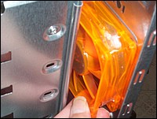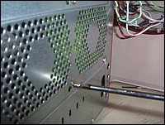

3. Reattach front bezel
.
Rear Fan
The rear fan can be 80,92 or 120mm in size and is installed in much the same was as the front fans.

1. Position fan inside the case, and secure with screws provided with the fan

